Matthew Bennett & Vanessa Van Den Elzen

Bryan Engelhardt

Econ 472: Time Series Analysis and Forecasting

May 15, 2019

**Forecasting Transaction Fees Earned Per Transaction: Bitcoin**

**Executive Summary**

In this paper, Vanessa Van Den Elzen and Matthew Bennett, students at the University of Wisconsin Oshkosh, address a small part of bitcoin’s complex formation, transactions fees, by predicting the amount of bitcoin received per transaction added to the blockchain. In order to predict the transaction fees earned per transaction, we used data showing the number of transactions per day and the total transaction fees per day and fitted the data to a time series decomposition model. With this forecast we predict a slight decline in the number of bitcoins given per transaction. Coupling this with other trends in the data, we forecast an increase in the number of transaction fees per block, which constitutes an increase in the number of transactions per day, overall.

**Introduction Section**

A crucial part of the makeup of bitcoin is that all of the transactions are recorded by miners in a general ledger referred to as the blockchain. Miners record these transactions in exchange for bitcoins. There are two main ways miners receive bitcoins as a reward for recording these transactions: by creating new coins, and by transaction fees. First, with each new block created, miners “create new” coins. However, the protocol of bitcoin requires that only so many new bitcoin can be created, referred to as block rewards. The block rewards are halved after every 210,00 blocks are mined, resulting in the estimated block reward of zero by the year 2140 (Easley). This means that over time, the rewards from “creating new” bitcoins decrease. The second way is through transaction fees, which rely on users giving the miners part of a bitcoin to record their transaction in the blockchain. Because the block rewards will eventually reach zero, the difficulty of mining new bitcoin continues to increase, and the longevity of bitcoin will eventually depend solely on transaction fees. Our efforts are centered around answering the question: What will the transaction fees for mining bitcoin be in the near future?

Because transaction fees are crucial to the survival of bitcoin and will continue to grow in importance as block rewards decrease, our motivation is to understand them and predict where they are headed in the future, and to additionally create an estimate for their value one month in advance. Answering this question is the foundation for answering many other questions about bitcoin such as “will it be profitable for miners once new coins can no longer be created?” and “is bitcoin sustainable once it reaches its limit?”, but also helps bring light to what may need to be fixed or done to keep the system alive, if anything is needed at all. In our forecasting efforts, we focused on the amount of bitcoin received to mine each transaction rather than the dollar value received per transaction, because that change of focus eliminates the variability in the market of bitcoin prices. Our research has concluded that if bitcoin prices continue to rise and cost remains constant, miners will be willing to add transactions to the blockchain for the same or a smaller percentage of the bitcoin value in the future, leading to bitcoin being able to be used in a wider variety of transactions, which increases the likelihood of bitcoin thriving as a cryptocurrency.

To help guide our efforts, we conducted a hefty amount of research on what other experts and researchers have found in regards to transaction fees and bitcoin mining prices. A large handful of articles reference popular and easy ways to be able to calculate transaction fees for miners to charge, such as an article on Coindesk, written by Daniel Palmer. Palmer does a nice job of summarizing that transaction levels are reaching all-time high levels but also summarizes the feats of 21 Inc., who developed an app that lets miners and bitcoin users alike to determine the optimal transaction fees to ask/charge. However, these fees are only able to be determined with recent data and only apply to the immediate present, rather than any form of a prediction farther than a few minutes into the future. One of our more useful articles we found, written by David Easley, also focused on predicting transactions fees, but rather than predicting the actual number of transaction fees, they focus on the number of miners entering the market due to the trends predicted in transaction fees. Lastly, in an article by BitcoinExchangeGuide, it was found that the “testnet” of a software called “Veriblock” drove up the number of bitcoin transactions considerably from late March 2019 to late April 2019, and after some minor changes and tests are made, it is expected that Veriblock will be reintroduced and continue to have an impact on the number of transactions occurring in the bitcoin market. These discoveries by other researchers helped direct our initial modeling and allowed us to account for the Variblock factor in the most recent trends in the transaction data.

We gathered our data from a database called Blockchain and used the number of bitcoin transactions per day and the total value of transactions per day, in bitcoin, to make up our data set. We forecasted the transaction fees using a time series decomposition model without a seasonal factor and an exponentially smoothed cyclical factor which concluded an overall decrease in the amount of bitcoin received per transaction over time. This allowed us to forecast a specific value of transactions, in bitcoin, one month in advance, in addition to predicting the continual stability of the bitcoin market due to a trend indicating an increase in the number of bitcoin transactions overall.

**Data Section**

Our data is essentially built around the number of transactions per day and the total transaction fees in a given day. Both of these data sets were found at blockchain.com, and we downloaded both data sets from the beginning of bitcoin, (which ended up being early 2009), and listed data values as every third day, rather than every day. We chose to take our data from here because not only did it give a complete history of the data of bitcoin transactions and the market in general, but we have also referenced a few articles that mention and use this very same data or other data from blockchain.com in their work. In addition, most other sources containing bitcoin data only included data from 2016 and more recent, and many sources stopped providing new data after 2018. As a result, blockchain.com provided the best and most consistent data. Because each different set of data covered the same range of time, we were able to divide each total transaction fee observation per day by the total number of transactions per day to give us an average transaction fee given per transaction, per day. The research we have conducted indicated a number of variables that should go into the calculation of a transaction fee to be charged, which repeatedly was found to be the size of a transaction and how long of a wait time each transaction is expected to have. These calculations, however, proved to only be useful in the very near future. We compared our “fees per transaction” data to these variables of transaction size and wait time, in addition to total miners revenue, the difficulty of mining, the market value of bitcoin, the hash rate of bitcoin, the total output volume of bitcoin, and the total volume of estimated transactions. We found that the total miner revenue and the market price of bitcoin provided strong regression results with very low p-values, but because the total revenue was a function including transaction fees, and transaction fees are a function of the bitcoin market price, both of these sets of data needed to be excluded. Total output volume and estimated volume of transactions were found to have no statistically meaningful relationship, and the remaining variables did have an impact on fees per transaction, but they failed to provide enough of an explanation to make a “good” prediction. As a result, we found that our best predictor of transaction fees per transaction is plotting the data against itself over time with no other variables involved.

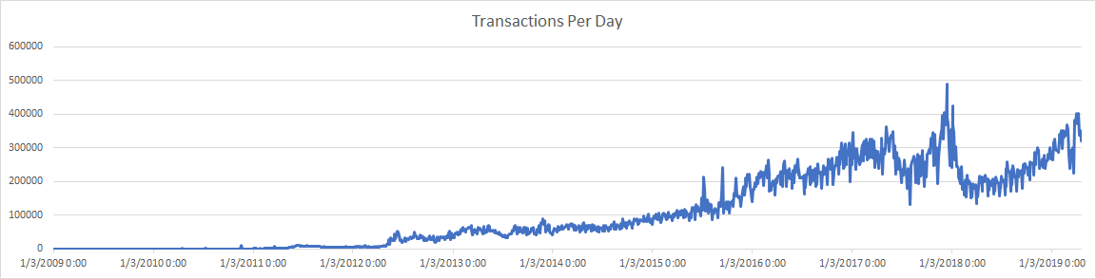

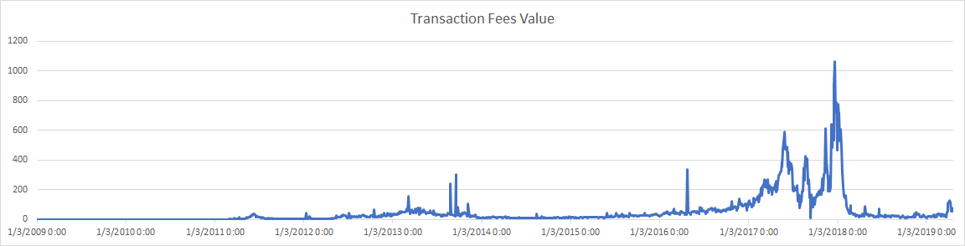

Note that the “Transaction Fees Value” is presented in the form of the number of bitcoins given in total per day, and not the dollar value of the transactions. If it were presented in the form of dollar value, the Transaction Fees Value would simply be multiplied by the market price of bitcoin per day.  
**Methodology**

Our method used to best forecast the transaction fees about a month in the future was by calculating a time series decomposition model and excluding a seasonal factor, as there was no apparent seasonal factor to be observed in the transaction fees. This model worked spectacularly in getting a rather smoothed overall trend in the data and really shone well when looking at the most recent observations (about a year and a half back, after the huge spike in the price of bitcoin in late 2017). We used a time series approach because we found that transaction fee amounts were impacted very little by outside forces; so much that any model chosen in relation to any factor of bitcoin was relatively worthless. The centered moving average (CMA) allowed us to calculate the center moving average trend (CMAT), which then gave us a cyclical factor (CF) as a ratio of the two, per three day period. This CF was then forecasted out by itself by using an exponential smoothing model using the data of the CF from the past 2 months, to give a somewhat predictable CF outside of the sample data. After using Excel’s solver to minimize the RMSE of the new, exponentially smoothed CF in relation to the CF itself, we had a very nice, smooth forecast that could give an adaptive prediction a month into the future. This isn’t something a typical time series decomposition (TSD) model can do, as TSDs cannot estimate a CF outside of the sample. This exponentially smoothed CF made our prediction slightly less accurate in the sample, but gave us a much better CF outside of the sample, especially when compared to just selecting a CF value and using it for all out-of-sample predictions like a typical TSD model. Because the forecast itself is comprised of the exponentially smoothed CF multiplied by the CMAT, which is a function of the CMA, the CMA is the only portion of the forecast that needed to be estimated into the future. In order to be as realistic as possible, we chose to take the average CMA for the last year, to help reduce the impact of a few slightly larger spikes in the data. The result gave a slightly decreasing CMA over time. This made our forecast have a heavier weight on the exponentially smoothed CF, due to the smaller amount of variation seen in the CMA. The last piece of our forecast is a form of an event study completed on the CMAT, where the effect of “Veriblock” on the transaction quantity was factored for by including an “if-statement” in Excel to adjust the CMAT during the length of time that Veriblock ran its course, which ended up being a one month window from late March to late April. By subtracting about 10% from the CMAT during this time window, the exponentially smoothed CF was able to quickly adjust and recover from the effects of the Veriblock impact.

**Results**

Below shows the entirety of our forecast for bitcoin earned per transaction. The blue line shows the data that is historically accurate, and the orange, smoother line shows the forecast. In terms of scale, a value of “0.001” means you would receive 0.1% of a bitcoin as a reward for completing a transaction. The majority of the time, the rewards for completing a transaction amount to about 0.01-0.02% of the value of a bitcoin. It is important to remember that the actual values also depend on the size of each transaction and the amount of time that bitcoin users wish to wait for their transaction to be completed. However, these factors appear to be random, and as our data is shown as the average amount per day, these sizes and wait times are irrelevant to our forecast.

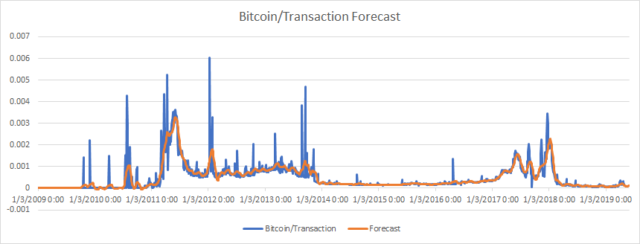

Below shows our forecast, but zoomed in to only include the most recent observations in the data, and to give a clearer idea of what the forecast looks like outside of the sample.

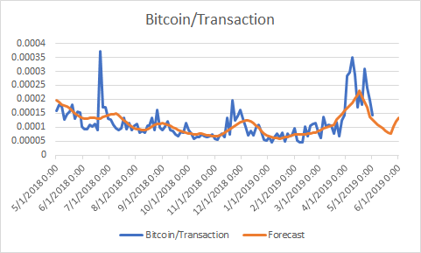

As you can see, the most recent data from late March to late April includes the effects of the Veriblock being implemented into the system of bitcoin transactions. As mentioned earlier, our model has an added factor to change the CMA of this period with the Veriblock technology. Our model, due to the exponentially smoothed CF, will react to the spike in price with Veriblock, but will also return to the similar state that is observed before the Veriblock implementation. In anticipation of Veriblock returning, it’d be possible to introduce a similar factor to the CF itself, allowing the Veriblock change to continue to be represented in our forecast. However, if Veriblock were to be introduced and stay in the system, the model would be able to react and change the forecast accordingly, with no needed interference. The results of our forecast are rather simple to interpret: without Veriblock technology in the system, there is an overall downward trend of bitcoin earned per transaction in the entirety of the data series, which is also predicted to continue outside of the sample, into the future. One month from now, we predict that the transaction fees earned per transaction will amount to about 0.0104% of a bitcoin. For a bitcoin miner this is not a good thing, as the amount earned per transaction over the last year amounted to about 0.011%. While this doesn’t seem like much, it amounts to over $18,000 per day in transaction fees alone, with a modest assumption of a market price of bitcoin at $5,000 (as of 05/09/2019, the market price of bitcoin sits at more than $6,100, according to coindesk).However, this decrease in fees earned per transaction is offset by an increase in the number of transactions over time, especially when including the possibility of Veriblock, which not only greatly increases the number of transactions in the market, but also supposedly will make it safer and easier to complete these transactions and faster and cheaper for bitcoin users to utilize bitcoin.

**Conclusion**

In an attempt to answer what bitcoin transaction fees might be one month in the future, we conducted research to determine the weighty impact that transaction fees present to the value of bitcoin mining and, using data collected from blockchain.com, developed a time series decomposition model to accurately and reasonably forecast the trend we might expect for bitcoin transaction fees. As concluded in our forecasting efforts, the amount of bitcoin earned per transaction is steadily decreasing over time, and by 6/1/19 we expect the fees earned per transaction to be lower than the average earned over the last year, by a small but impactful amount. This, however, is subject to the implementation of Veriblock technology which will likely increase the fees earned per transaction by a noticeably different amount, in addition to increasing the ease and convenience of completing transactions.

**References**

Easley, David, et al. “From Mining to Markets: The Evolution of Bitcoin Transaction Fees.”

Journal of Financial Economics, North-Holland, 11 Mar. 2019,

www.sciencedirect.com/science/article/pii/S0304405X19300583?via=ihub.

M, Krystle. “Veriblock Blockchain Project Creates New Debate For Posting Over 25% Of BTC

Transaction Numbers.” BitcoinExchangeGuide, 27 Apr. 2019,

bitcoinexchangeguide.com/veriblock-blockchain-project-creates-new-debate-for-posting-over-25-of-btc-transaction-numbers/.

Palmer, Daniel. “21 Inc Launches Bitcoin Transaction Fee Prediction App.” CoinDesk,

CoinDesk, 10 Feb. 2016, www.coindesk.com/21-inc-bitcoin-fee-prediction-app.